**Database Lab**

**Report**

**Lab 01**

Sharjeel Akram

BSCS-2019-60

Sir Shafi Ullah

In the lab manual we have been given two tasks for python code using **tkinter** library.

In the task 1, we have to create a login page in which if we enter our email and password and click on login page then a new window should be opened and previous one should be closed. But if email or password is wrong it will display a message on login page that it has some error.

When I ran my code first it will display a login page on which you can enter your email and password to login as shown in the below picture;

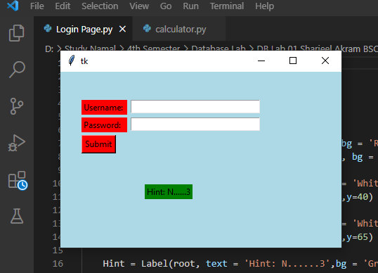

Then I entered my email and password which is already stored in my code and a new window will be opened as shown in the below picture.

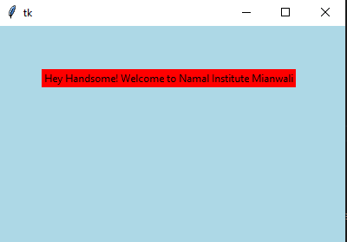

But when I entered wrong email or password it displays a message of Invalid email or password on the screen as shown in the picture.

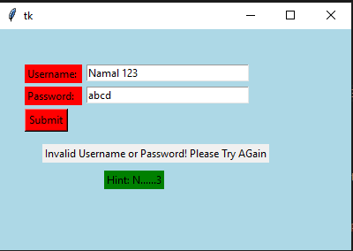

Task 2:

In the lab manual task 2 were given to develop a calculator using same tkinter library.

First I used tkinter library to make a GUI of calculator in which numbers are shown with the basic math operation and there is button of “=” which will give the output of any operation on the screen and there is button of clear which clear all the input and output.

When I run my code it displays a certain window of calculator as shown in the picture.

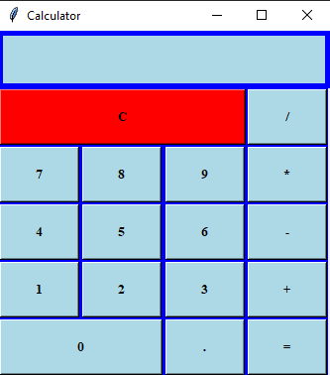

For addition when we enter our input in the input field and it displays as shown in below picture;

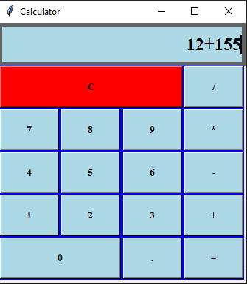

But when we enter the “=” sign it will display output according to our numeric function whether it is addition, subtraction, division or multiplication.

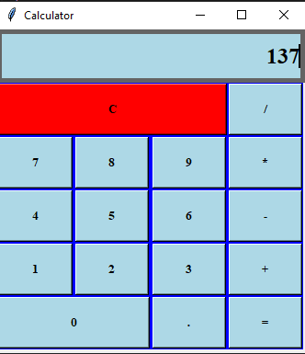

After pressing on “=” it is displaying the output of previous picture input so it shows that function are working properly.

But when we enter On **C** button it will clear the input field and will be ready for next input.

After clicking on clear button it has cleared the input field.

